Software Requirements Specification

**Apple DWH Solution**

Table of Content

**Versions Management** 3

**TBD Management** 3

**Overview** 3

Business Background 3

Benefits 4

**Requirements** 4

Business Requirements 4

Functional Requirements 5

Non - Functional Requirements 5

**Solution Sketch** 6

DWH Solution Sketch 6

Source Tables structure 6

**Scheme structure** 7

Star Scheme 7

Physical Diagram 7

Logical Diagram 7

Snowflake Scheme 7

Physical Diagram 7

Logical Diagram 8

**User Access and Rights Matrix** 8

**Data Warehouse Architecture** 9

**Partitioning Fact Table** 9

**Glossary** 10

# **Versions Management**

|  |  |  |
| --- | --- | --- |
| Version | Date | Description |
| 1.0 | 07/24/2022 | Document created, (Added Version Management, TBD Management, Overview, Requirements, and Solution Sketch chapters). |
| 2.0 | 07/25/2022 | Added Scheme Structure chapter (Logical Diagram) |

# **TBD Management**

|  |  |  |  |  |  |
| --- | --- | --- | --- | --- | --- |
| ID | Short description | Date of creating | Status | Date of determination | Determination Version Number |
| TBD – 01 | Which reports? | 07/24/22 | Non – determined |  |  |
| TBD – 02 | Oher business requirements | Non – determined |  |  |
| TBD – 03 | Oher functional requirements | Non – determined |  |  |
| TBD – 04 | Oher non – functional requirements | Non – determined |  |  |
| TBD – 05 | Source tables structure, e.g. add more tables | Non – determined |  |  |
| TBD – 06 | Non – determined |  |  |
| TBD – 07 | Non – determined |  |  |
| TBD – 08 | Non – determined |  |  |
| TBD – 09 | Overview | Non – determined |  |  |

# **Overview**

As an example, I wanted to demonstrate Apple sales to show specifics of building DWH in this sphere. (TBD - 09)

## Business Background

Apple Inc. is an American multinational technology company that specializes in consumer electronics, software and online services. Apple is the largest technology company by revenue and it is the world's second biggest company by market capitalization, the fourth-largest personal computer vendor by unit sales and second-largest mobile phone manufacturer. It is one of the Big Five American information technology companies, alongside Alphabet, Amazon, Meta, and Microsoft. In fact, Apple Has More Cash than the US Government.

Here are some most popular products:

1. IPhone
2. Services
3. Mac
4. IPad
5. Wearables, Home and Accessories

Nowadays apple sells so many products every second, minute, hour that it would be hindsight enough not to have a picture expressed in data about them. One of the most reasonable solution that can be used to store all these data is a DWH.

## Benefits

1. **Time saving.** In the modern fast-paced world of cutthroat competition, your capacity as a business is to swiftly make refined decisions is essential to outpace your opponents. A DWH provides access to all required data in a matter of minutes, so you and your employees do not have to dread an approaching deadline. All you need to do is deploy your data model to acquire data within seconds. Our DWH solution allow you to do that without using a complex query or machine learning. With data warehousing, your business will not have to rely on the 24/7 availability of a technical expert to troubleshoot problems associated with retrieving information. This way, we can save plenty of time.
2. **Improves Data Quality.** The refined quality of data helps guarantee that Apple Company’s policies are based on precise information about your corporate exertions. By understanding the data warehousing meaning, we can transform data from multiple sources into a shared arrangement. Consequently, we can ensure the reliability and quality of corporate data. This way, we can identify and remove replicated data, poorly recorded data, and any other errors.
3. **Increases BI – operations performance.** We can use a data warehouse to gather, assimilate, and derive data from any source and set up a process to leverage business analytics. As a result, BI will improve rapidly, owing to the capability of effortlessly integrating data from distinct sources.

With a data warehouse in place, every team member can have an integrated understanding of all the relevant information in a timely manner.

1. **Storing Historical Data.** Data Warehouse allows storing large volumes of historical data from operational databases. It is easy to investigate different time phases and inclinations that can be innovative for your company. Thus, with the right and real-time data in your hands, you can make superior corporate decisions concerning business strategies. Moreover, predicting the results of business processes is a significant aspect. It can be challenging to forecast the future without a tangible understanding of our historical achievements and letdowns of Apple Inc. Thus, using EDW gives us an advantage in business procedures.

# **Requirements**

## Business Requirements

|  |  |
| --- | --- |
| Business Requirements | |
| ID | Requirement Description |
| BR – 01 | Get an actual information about different separate product sales |
| BR – 02 | Get reports structured by different time dimensions to decrease amount of time needed to create right report. |
| BR – 03 | Improve data storing performance to have an ability to target different offers |
| BR – 04 | Improve data access performance |
| BR – 05 | Improve security of data storages |
| BR – 06 | Improve the quality of stored data |
| BR – 07 | Ensure long - lasting and effective storage of historical data |
| TBD – 02 | … |

## Functional Requirements

|  |  |
| --- | --- |
| Functional Requirements | |
| ID | Requirement Description |
| FR – 01 | System should give an opportunity to see sales statistics divided by different time dimensions |
| FR – 02 | System should give an opportunity to see sales statistics divided by different geo dimensions |
| FR – 03 | System should give an opportunity to choose geo and time dimensions that user interested in to see in report |
| FR – 04 | System should store time and geo dimension packages on company servers at least 5 years from the date of commissioning |
| FR – 05 | System should generate daily/weekly/monthly reports automatically and store them on company servers 5 years |
| FR – 06 | System should give an opportunity to increase or decrease the amount of time the data will be stored on servers |
| FR – 07 | System should give an opportunity to make reports manually (not only at the end of day/week/month) |
| FR – 08 | System should give an opportunity to configure reports in Data Mart Level (Except of FR – 01 / FR - 02) (… TBD – 01) |
| FR – 09 | System should automatically update an information about actual sales data. |
| FR – 10 | DWH Architecture should consist of Storage, Cleansing, Data Warehouse, Data Warehouse Prepare Star Cleansing Level, STAR – Cleansing and STAR Levels (Data Warehouse Architecture Chapter) |
| FR – 11 | System should have an opportunity to be built using either STAR or SNOWFLACKE Schema |
| TBD – 03 | … |

## Non - Functional Requirements

|  |  |
| --- | --- |
| Functional Requirements | |
| ID | Requirement Description |
| NFR – 01 | System should give an opportunity to access data in any time (24 hours a day) |
| NFR – 02 | System should be integrated with Banking API |
| NFR – 03 | System should update data no longer than 5 seconds (except of complex queries) |
| NFR – 04 | System should have an actual back up version of current region sales on master server and current region server |
| NFR – 05 | System should have an opportunity to store an information about hew opened stores (extensible) |
| NFR – 06 | System should have an opportunity to use it (or its separate parts) in other company’s products(other DWH’s e.g.) |
| NFR – 07 | System should have built according to ETL philosophy |
| TBD - 04 | … |

# **Solution Sketch**

## DWH Solution Sketch

At the diagram above you can see Conceptual Sketch Diagram that shows stages of data transforming: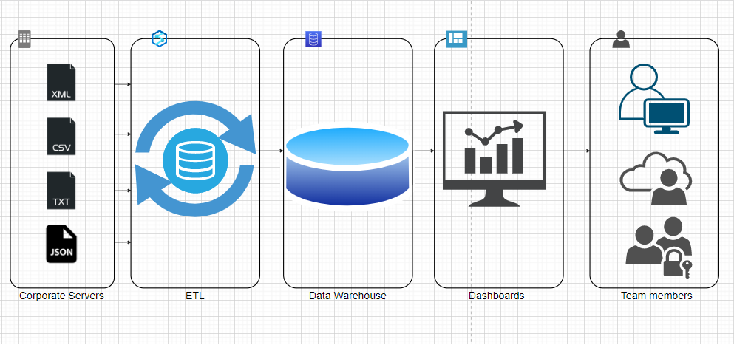

Picture 1 - [DWH Data Transformation sketch](https://drive.google.com/file/d/10h7tpl3ZA6PTKaClzNf1Xgne3ohdrE5x/view?usp=sharing) (Link)

## Source Tables structure

|  |  |
| --- | --- |
| Name | T_products |
| Description | Table contains data about different products |
| Data Source | Flat files or operational databases |
| Frequency of updating | Automatically every week / manually |
| TBD – 05 | … |

|  |  |
| --- | --- |
| Name | T_stores |
| Description | Table contains data about different stores and their locations |
| Data Source | Flat files or operational databases |
| Frequency of updating | Automatically every month / manually |
| TBD – 06 | … |

|  |  |
| --- | --- |
| Name | T_customers |
| Description | Table contains data about all customers |
| Data Source | Flat files or operational databases |
| Frequency of updating | Automatically every customer creates new account on web site / manually |
| TBD – 08 | … |

|  |  |
| --- | --- |
| Name | T_countries |
| Description | Table contains data about different countries and regions |
| Data Source | Flat files or operational databases |
| Frequency of updating | Automatically with opening new stores or sales markets / manually |
| TBD – 07 | … |

# **Scheme structure**

## Star Scheme

## Physical Diagram

TBD

## Logical Diagram

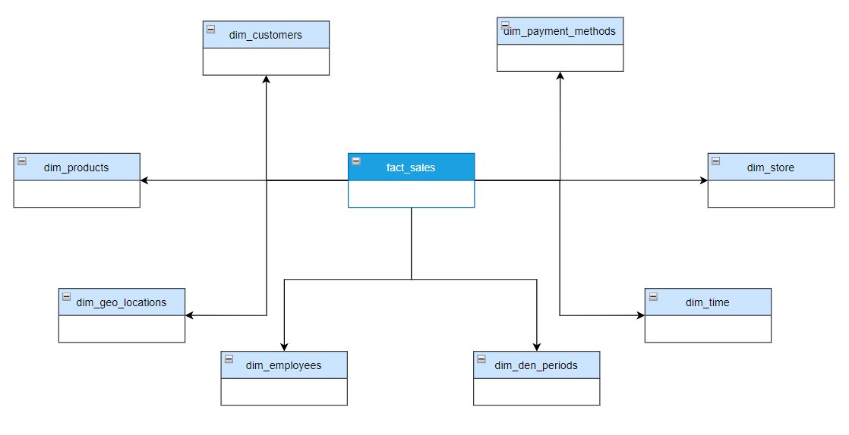

Picture 3 - [Logical Diagram](https://drive.google.com/file/d/1KqppAhMj9edn3CljhLuN5aDDsmBu0UIH/view?usp=sharing) (Link)

## Snowflake Scheme

## Physical Diagram

TBD

## Logical Diagram

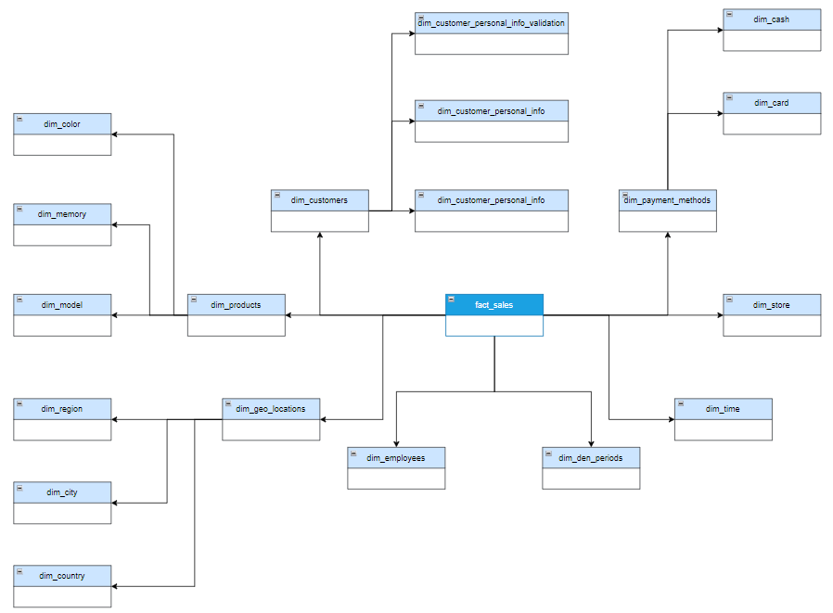

Picture 5 - [Logical Diagram](https://drive.google.com/file/d/1a9XCwER_AamCMXMwhrDoYYRC90YwF9nf/view?usp=sharing) (Link)

# **User Access and Rights Matrix**

|  |  |  |  |  |  |
| --- | --- | --- | --- | --- | --- |
| User  Function | Admin | Super users (Chiefs, CO – founders etc.) | Manager | BI – Analyst | Other Systems (TBD) |
| DML | CRUD | CRUD | CRUD | CRD | CRUD |
| DDL | CRUD | CRUD | CRUD | CRUD | CRUD* |
| DCL | L | CRUD | L | L | L |
| DQL | CRUL | CRUD | CRUL | CRUD | CRUD |

* C – create
* R – read (COST > 50)
* U – update
* D – delete
* L – list (COST < 50)

*(exp. can call creating entities, queries)

# **Data Warehouse Architecture**

|  |  |  |  |
| --- | --- | --- | --- |
| Level Type | Object Name | Tablespace | Description |
| Storage level | SA_CUSTOMERS | ts_SA_CUSTOMERS_DATA_01 | Loads data from flat files, stores data about customers/products |
| SA_PRODUCTS | ts_SA_PRODUCTS_DATA_01 |
| DW Cleansing Level | DW_CL | ts_DW_CLEANSING | Loads from stage level |
| SA Date | SA_DATE | ts_sa_date | Contains all info about dates/locations |
| DW Level | DW_DATA | ts_DW_DATA_01 | Loads data from cleansing level and preparing it for to the 3 normal form |
| DW Prepare Star Cleansing Level | SAL_DW_CL | ts_SA_DW_CL_01 | Loads data from DW system. Contains views and objects from DW - Level |
| STAR - Cleansing | SAL_CL | ts_SA_CL_001 | Loads data from DW_CL, but clean some redundancy if are some |
| STAR Level | DM_FCT_SALES | ts_SA_FCT_SALES_01 | INFO |
| DM_BORROWERS | ts_SA_BORROWERS_01 |
| DM_CUSTOMERS | ts_SA_DIM_CUSTOMERS_01 |
| DM_PRODUCTS | ts_SA_DIM_PRODUCTS_01 |
| DM_GEO | ts_SA_DIM_GEO_01 |

# **Partitioning Fact Table**

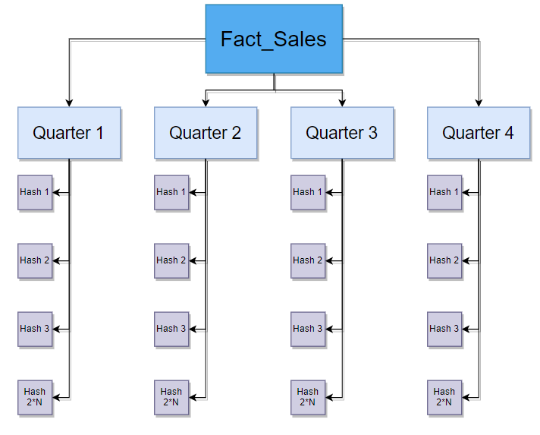

Picture 6 - [Partitioning Fact Table](https://drive.google.com/file/d/1zI7lp4bh-fcQjHRa-U6Rf8kwjx2uSpq8/view?usp=sharing) (Link)

# **Glossary**

* Borrower
* Customer
* Cost
* Dashboard
* Logical Scheme
* Physical Scheme
* TBD
* DWH
* EDW
* ETL
* API